Bamboo Remote Agent Installation

Revision Information

Ver. 2.0– July 02, 2020 ; Sandeep Nalam

**Abstract**

Instructions for the installation and configuration of Atlassian Bamboo remote agents on our enterprise platforms (Java & Win 7 machine ) build hosts so they can participate in Continuous Integration.

**Bamboo Remote Agent Installation**

* Create Folder for bamboo remote agent to install in C:\**bamboo-agent-1** ( Common path)

Create one more folder under C:\bamboo-agent-1 directory “**bamboo-home**”

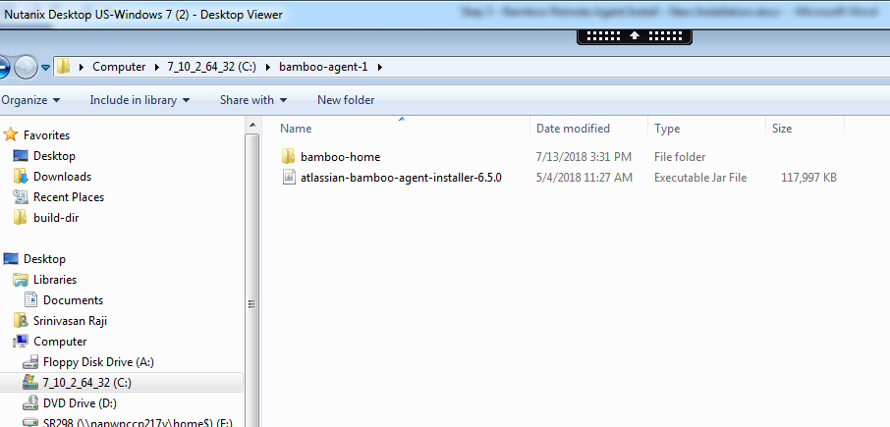

* Install JAVA 1.8 in your machine and set path variable under system

**PATH** : %JAVA_HOME%\bin; C:\Program Files\Java\jdk 1.8.0_161\JRE\Bin;

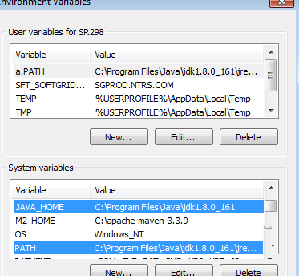

* Create a folder bamboo-agent-1 under C:\ dir.
* Copy bamboo-remote-agent-installer “atlassian-bamboo-agent-installer-6.5.0.jar “ to Installation Folder(C:\bamboo-agent-1)

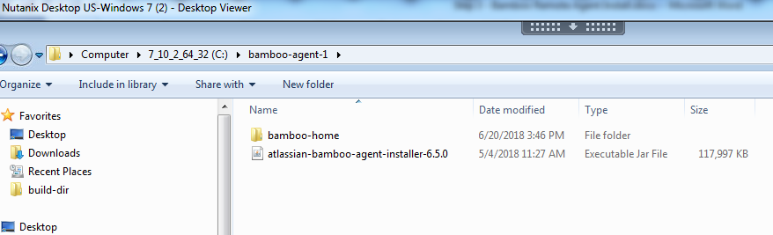

* Check if JAVA is available using “java -version”

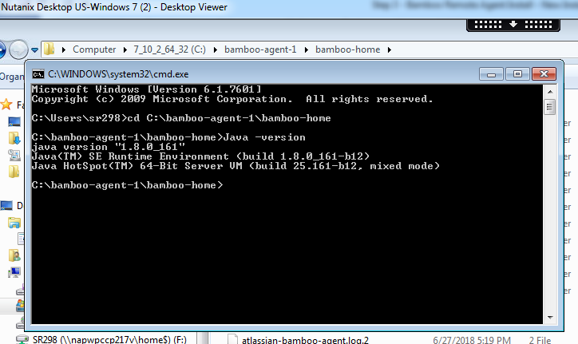

* Automated installation:
  + Right click on **Bamboo-Install-PROD-Agent** script and Select the **Run as Administrator** option and it will install the Agent.



* Manually:
  + Install bamboo-remote-agent; Go to directory where you kept jar file.

**Production Bamboo –**

**Installation :**

java –jar –Dbamboo.home=C:\bamboo-agent-1\bamboo-home atlassian-bamboo-agent-installer-6.5.0.jar https://bamboo.ntrs.com:8443/agentServer installntservice

**Uninstallation** :

java –jar –Dbamboo.home=C:\bamboo-agent-1\bamboo-home atlassian-bamboo-agent-installer-6.5.0.jar https://bamboo.ntrs.com:8443/agentServer uninstallntservice

**UAT Bamboo –**

**Installation :**

java –jar –Dbamboo.home=C:\bamboo-agent-1\bamboo-home atlassian-bamboo-agent-installer-6.5.0.jar  <https://bamboo-uat.ntrs.com:8446/agentServer/> installntservice

**Uninstallation** :

java –jar –Dbamboo.home=C:\bamboo-agent-1\bamboo-home atlassian-bamboo-agent-installer-6.5.0.jar  <https://bamboo-uat.ntrs.com:8446/agentServer/> uninstallntservice

Note: If you face any issues running this cmd then type it manually.

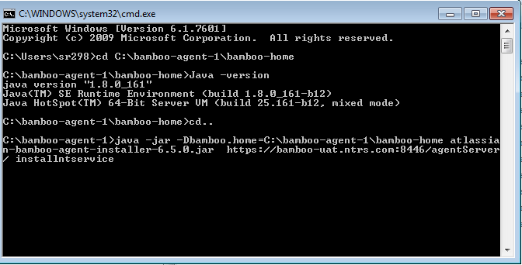

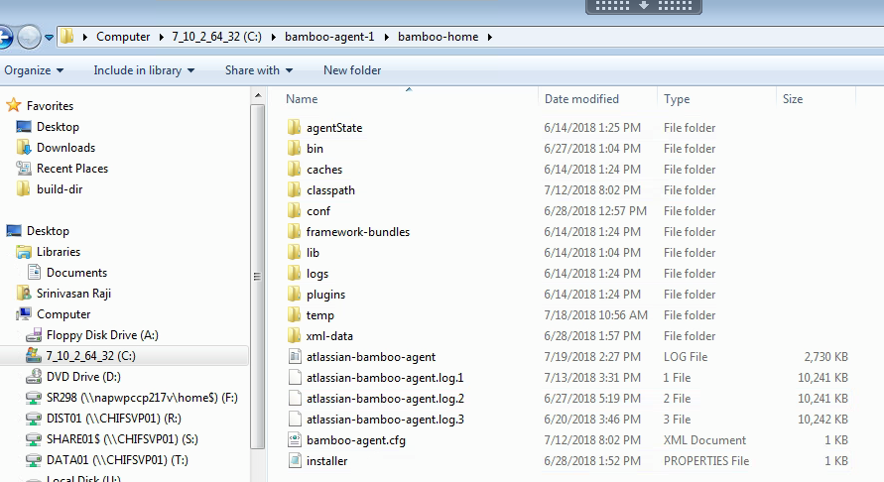

Note:

* Changes need to be done to C:\bamboo-agent-1\bamboo-home\conf\wrapper.conf
* Ensure the line **wrapper.java.command** references the path to the java.exe, int his case:

wrapper.java.command=C:\Program Files\Java\idk1.8.0_45\bin\java

**Bamboo-capabilites:**

Please copy the property file from the shared path to the installation system under **C:\bamboo-agent-1\bamboo-home\bin** –

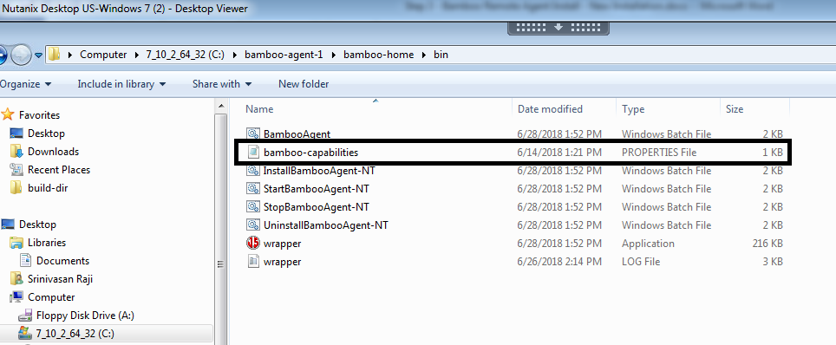

***Update the Capabilities path’s based on the new installation and if you want any other capabilities also you can add them base on the requirement.***

**Bamboo- Capabilities:**

agent.Type=Automation

system.builder.mvn3.Maven\ 3=C:\\apache-maven-3.3.9

system.jdk.JDK\ 1.8.0_161=c:\\Program Files\\Java\\jdk1.8.0_161

system.git.executable=C:\\Program Files\\Git\\bin\\git.exe

* Once Installation is complete then go to **Start -> Services** run as an Administrator.

Navigate to Bamboo Remote Agent - > Properties ->Log on - > This Account -> Enter your Lan credentials (We are running bamboo agent under your profile, It supposed to run under “Local System Account” but we couldn’t do that. There is an access restriction to lunch browser when agent running as a local system account. We are working on it.)

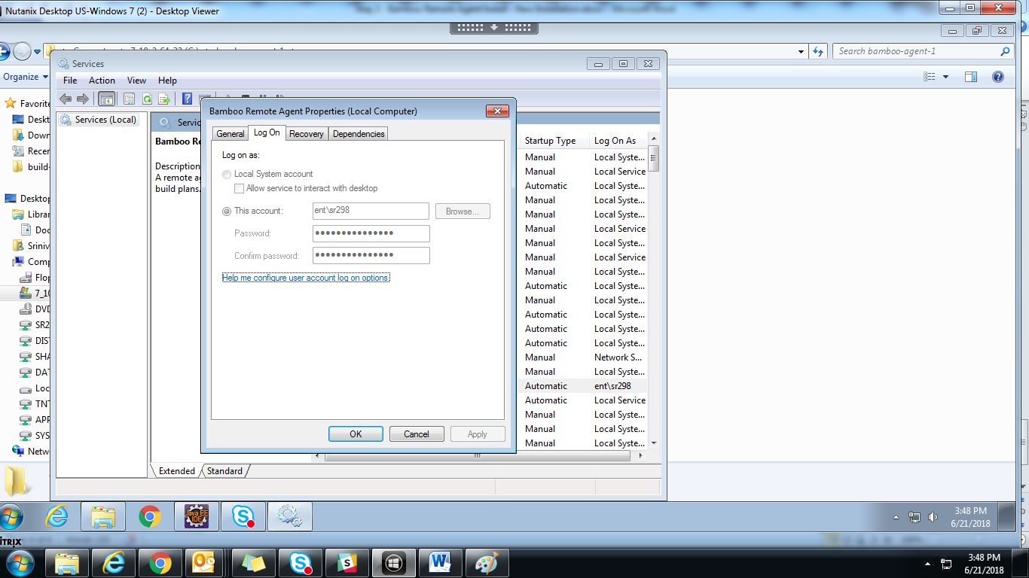

* Stopping Bamboo Remote Agent : Go to Service -> Stop
* Uninstalling Bamboo Remote Agent Service : Go to directory where you kept Jar File.

java –jar –Dbamboo.home= C:\bamboo-agent-home atlassian-bamboo-agent-installer-6.5.0.jar https://bamboo.ntrs.com:8443/agentServer uninstallntservice

* DN - start*

Observe the service log file, it will try to authenticate against the server. It will fail!

Need to make GTR (General Technical Request) to “EMS CI” team to authorize the request from a new bamboo-agent

Observe the service log file, you will see msg “blah” saying that you need to install the bamboo certificate

Cd c:\Program Files\Java\jdk1.8.0_64\jre\lib\security

Run this cmd “Keytool -list -keystore cacerts -alias bamboo”, observe that “nothing” is reported (certificate is not yet installed)

Ensure service is stopped

Run this cmd (as administrator) “keytool -import -alias bamboo -file bamboo.cer -keystore cacerts”

“enter keystore password”: changeit

“trust this certificate?” : Y

“Certificate was added to keystore” – success!

Cart file is here if needed (copy to security folder) 

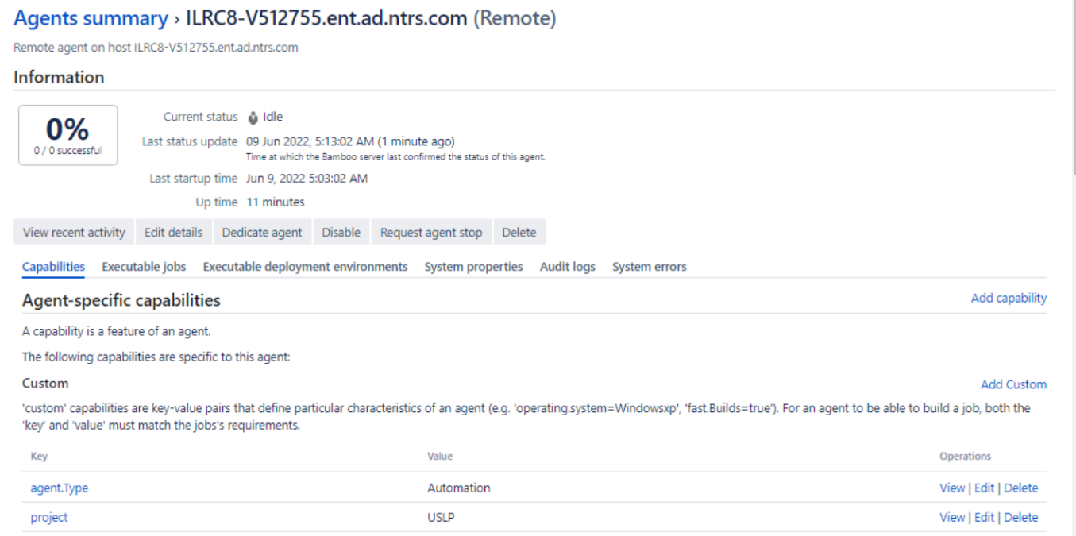

(screen shot from IT support)

**GIT is missing**

Stop service, Install GIT, restart service

 the bamboo agent is unable to connect with bitbucket to pull the source code. Please see the log <https://bamboo.ntrs.com:8443/download/ATR-MLTR-JOB1/build_logs/ATR-MLTR-JOB1-243.log>

This support ticket describes the issue [[BAM-21467] Bamboo stops communicating to Bitbucket Server and Data Center after updating to Git for Windows 2.33.0(2) or newer - Create and track feature requests for Atlassian products.](https://jira.atlassian.com/browse/BAM-21467)

Perform update to C:\Program Files\Git\etc\ssh\ssh_config file as suggested

Host 127.0.0.1

HostkeyAlgorithms +ssh-rsa

PubkeyAcceptedAlgorithms +ssh-rsa

Success – resolved git connection problem ! Agent is now able to download source code

**Maven is missing**

Build log file shows “can’t find C:\apache-maven-3.8.3\bin\mvn.bat

Because … it’s installed under C:\Program Files\apache-maven-3.8.3

Copy maven folder to root

**Fixed!**

Can’t restart service (no admin access) – agent config file defines where mvn is installed

* DN – end *

**Additional Details Bamboo Plan :**

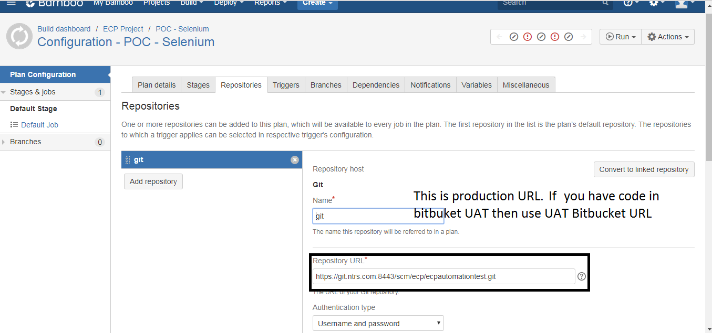

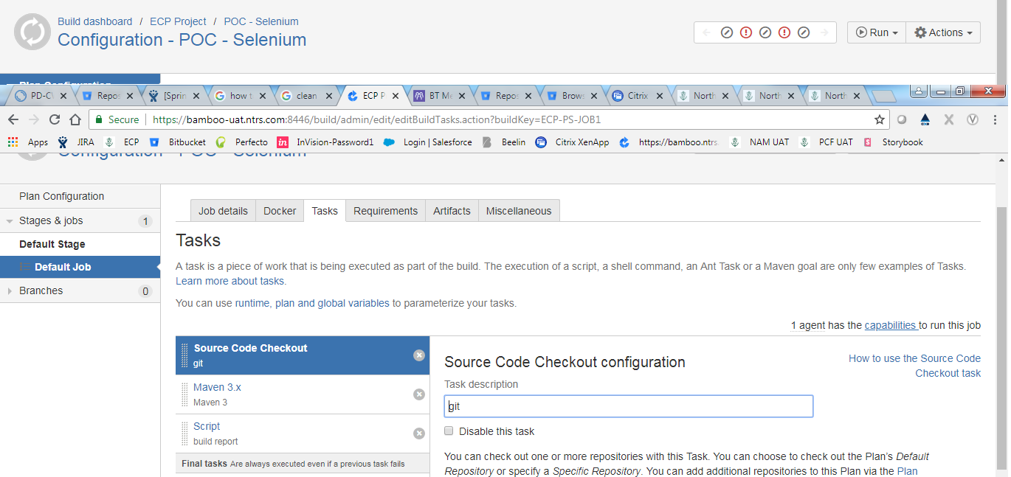

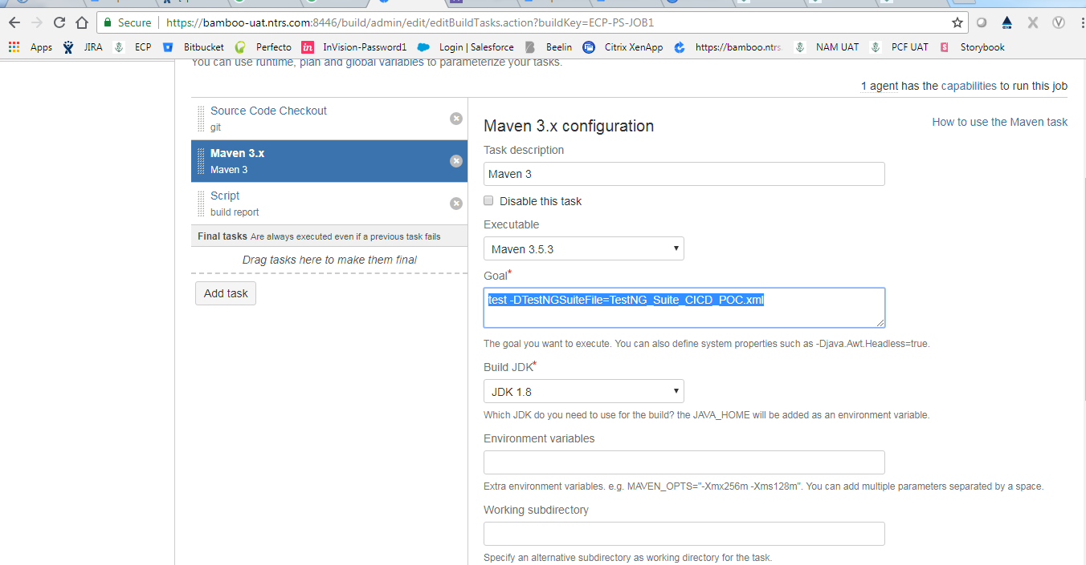

To run Test NG File : Goal : test -DTestNGSuiteFile=**TestNG_Suite_CICD_POC**.xml

Report Attachment :

